**Madan Bhandari Memorial College**

Affiliated to Tribhuvan University

Baneshwor, Kathmandu



**A Project Report of E-Governance**

**Online Birth Certificate Correction Request Portal**

**“Janmadarta sudhaar”**

**Submitted By Submitted To**

Aayush Basnet Department of CSIT

Nischal Kunwar Madan Bhandari Memorial College

Utshav Paudel Baneshwor, Kathmandu

**Date:**

**Declaration**

We hereby declare that the project for e-commerce titled as “**Janmadarta sudhaar**” which is online birth certificate correction portal submitted, is a record of an original work done by the team consisting of Aayush Basnet, Nischal Kunwar, and Utshav Paudel under the guidance of our lecturer Aavash Khadka.

This lab report for E-Governance site has been created by following the standard structure.

Signature: .......................................................

Date: ...............................................................

**ACKNOWLEDGEMENT**

We would like to express our heartfelt appreciation to everyone who contributed to the successful completion of this report on E-Governance. This project would not have been achievable without their support and guidance.

First and foremost, we extend our deepest thanks to our respected lecturer, Mr. Aavash Khadka, whose commitment and profound insights have significantly shaped our comprehension of e-commerce. His constructive feedback has been invaluable in enhancing this report.

We also wish to acknowledge the coordinator of the CSIT department, Mr. Phul Babu Jha, for his unwavering encouragement and oversight throughout this academic endeavor.

Additionally, our gratitude goes to the entire CSIT department of Madan Bhandari Memorial College for providing essential resources and a conducive learning environment, which has been crucial in our understanding of e-commerce

**Contents**

Introduction............................................................................................................

Objective................................................................................................................

Technologies Utilized............................................................................................

Proposed System: .................................................................................................

Overview...................................................................................................

Functional Requirements...........................................................................

Non-functional Requirements...................................................................

Implementation Requirements...............................................................................

Hardware Requirements: ..........................................................................

Software Requirements: ............…...........................................................

Implementation...................................................................................................

Apply for correction…………………………………………………….

Track your application……………………………………………….....

Screenshots ……………………………………………………………………

Conclusion...........................................................................................................

References...........................................................................................................

**Introduction**

This report outlines the design and implementation of the web-based system “Online Birth Certificate Correction Request Portal”. The goal of this platform is to simplify and digitize the correction process of birth certificates, reducing the need for physical visits and manual processing.

In many regions, individuals face challenges correcting minor or major errors in birth certificates due to lengthy, paper-based procedures. This portal aims to make that process more accessible by allowing users to request correction online, upload necessary documents, track their requests, and receive updates from the concerned authority.

The portal will offer features such as request form submission, document uploads, admin verification, approval/rejection workflows, and real-time status tracking. For admin users, the platforms provide tools to manage requests, reviews submissions, and communicate decisions efficiently.

Our team collaboratively designed and developed this portal to improve accessibility, transparency, and speed in civil documentation services using modern web technologies.

# **Objective**

The main objectives of the project are as follows:

1. Develop a Functional Online Request Platform

Build a web-based system that allows users to submit correction requests for their birth certificates along with supporting documents.

1. Enable Transparent Request Tracking and Processing

Implement a feature for users to check the status of their request and receive notifications at different stages like verification, approval, or rejection.

1. Digitize Admin Workflow for Better Efficiency

Provide admin users with a dashboard to review, approve/reject, and manage correction requests, reducing paperwork and manual effort.

**Technology Used**

The development of the website's front end and back end involved the utilization of several robust tools and technologies. These tools were carefully selected to ensure the creation of a high-quality, efficient, and scalable E-Governance website for Online Birth Certificate Correction Request Portal. The following are the key tools and technologies employed:

1. WordPress:

WordPress, a widely acclaimed content management system (CMS), served as the foundation for the website's development. Leveraging its user-friendly interface and extensive plugin ecosystem, WordPress facilitated the efficient creation and management of the website's content, ensuring seamless updates and customization. Themes: WordPress users may install and switch among many different themes. Themes allow users to change the look and functionality of a WordPress website without altering the core code or site content. Every WordPress website requires at least one theme to be present.

1. MySQL:

MySQL, a powerful open-source relational database management system, played a critical role in the storage and retrieval of data for the website. By utilizing MySQL, we ensured the efficient management of complex data structures, enabling seamless interactions between the website and the underlying database.

1. XAMPP:

XAMPP, an all-in-one development environment, was instrumental in setting up a local server environment for testing and development purposes. With XAMPP, we were able to simulate the website's functionality in a secure and controlled environment, ensuring smooth integration of the various components and features.

By harnessing the power of these tools and technologies, we achieved a robust and scalable E-Governance website for Online Birth Certificate Correction Request Portal. The careful selection and integration of these technologies ensured the website's stability, security, and optimal performance, contributing to a seamless user experience and effective governance in the education sector.

**Proposed Website**

The proposed system, Online Birth Certificate Correction Request Portal, is designed to provide a streamlined, user-friendly platform for citizens to submit and track correction requests for birth certificates.

A central goal of the portal is to streamline the correction request process by offering structured forms where users can input necessary details and upload required documents. The interface will be designed to guide users through each step with clarity, minimizing confusion and ensuring that all essential information is collected accurately.

Another core objective is to facilitate transparent communication between applicants and the administrative authority. Once a request is submitted, users will be able to track its status in real-time, receiving updates such as “Pending,” “Under Review,” “Approved,” or “Rejected.” This feature not only enhances transparency but also builds user confidence in the system.

For the administrative side, the platform will include a robust backend dashboard where authorized personnel can log in, review submissions, verify documents, update statuses, and communicate feedback or decisions to the applicants. The system will also include filtering and search functionality to efficiently manage a large number of applications.

Security is a key priority for this system. The portal will include secure user authentication, encrypted data handling, and file upload validations to protect sensitive personal information. By emphasizing these features, the portal aims to create a reliable and trusted environment for citizens to request birth certificate corrections in a convenient and efficient manner.

**Functional Requirement**

The functional requirements for “**Janmadarta sudhaar**” Online Birth Certificate Correction Request Portal website are defined to ensure that citizens and administrators can effectively utilize the system and achieve their respective objectives. These requirements outline the specific functionalities that the website should possess. The functional requirements for the website are as follows:

1. User Registration and Login

The system must new users to create an account by providing basic personal information such as name, email, phone number, and password. After registration, users should be able to log in securely using their credentials.

1. Correction Request Form Submission

Users must be able to submit correction requests by filling out a structured form. This form should capture key fields such as the certificate holder’s name, date of birth, place of birth, parent names, and a detailed description of the correction required.

1. Admin Review Panel

The portal must provide an administrative dashboard for authorized government or verification staff. From this panel, admins can view all submitted requests, filter them based on status or submission date, review uploaded documents, and take actions like **Approve**, **Reject**, or **Request for More Information**.

1. Notification System

The system must notify users of important updates, such as when a request is received, its status changes, or additional documents are needed. Notifications can be delivered via email or any other message system.

**Non-functional Requirement**

In addition to the functional requirements, the “**Janmadarta sudhaar**” Online Birth Certificate Correction Request Portal should also adhere to non-functional requirement to ensure optimal performance, usability, and security. The non-functional requirements for the website are as follow:

1. Security and Data Protection

The system must ensure the confidentiality and integrity of all user-submitted data using encryption for sensitive information and validating file uploads. Protection against common web threats (e.g., SQL injection, XSS) is also essential.

1. Scalability

The system should be scalable enough to handle a growing number of users and requests over time without performance issues. Whether it's a small municipality or a large city using the system, it should function efficiently under increased load.

1. Usability and Accessibility

The user interface must be clean, responsive, and easy to navigate for users of all ages and backgrounds. The system should follow basic accessibility standards (like readable fonts, keyboard navigation, and color contrast) to support people with visual or physical impairments.

1. Performance and Response Time

The portal should respond to user actions (such as form submission or request tracking) within a few seconds. Page loads, dashboard data retrieval, and file uploads/downloads should be optimized to ensure a smooth and frustration-free user experience.

**Implementation Requirements**

**Hardware Requirement**

|  |  |
| --- | --- |
| Processor | 13 or better |
| RAM | 4 GB or higher |
| Hard Disk Space | Minimum 5GB or higher |

**Software Requirement**

|  |  |
| --- | --- |
| Operating System | Windows, MACOS, Linux or any other  platform that supports web browser |
| Database Management System | MySQL |
| Web Server | Apache |
| Client Application | Any Web Browser |

**Implementation**

The implementation of the “**Janmadarta sudhaar**” Online Birth Certificate Correction Request Portal was carried out using modern web technologies, primarily leveraging the WordPress content management system. The system is designed to provide a seamless experience for citizens requesting corrections to their birth certificates while allowing administrators to efficiently manage and process those requests.

1. **Apply for correction page**

The Create Request page is designed to allow users to submit a correction request for their birth certificate. This page is accessible only to registered and logged-in users. It contains a structured form where users can input all the necessary details related to the correction they wish to make.

The form includes fields such as full name as per the existing birth certificate, corrected full name, date of birth, place of birth, father's name, mother's name, and the type of correction requested. A text area is provided for the user to explain the correction in detail. Additionally, the page allows users to upload required supporting documents, including a copy of the existing birth certificate and other proof documents such as a citizenship certificate or school records.

Once the form is filled and the documents are uploaded, the user can submit the request. The system stores the data in the database and redirects the user to the tracking page to monitor the progress of their request.

The page is implemented using a form builder plugin in WordPress, ensuring ease of use and proper data validation before submission. All uploaded files are securely stored, and proper file formats are enforced during upload.

2**. Track Application Page**

The Track Request page allows users to monitor the status of the correction requests they have submitted. Each user has access to their own request history, which is displayed in a tabular format.

The table includes important information such as the request ID, submission date, type of correction requested, and the current status of the request. Statuses are updated in real-time and can include stages such as Pending, Under Review, Approved, or Rejected. If a request has been reviewed, any remarks provided by the administrative staff are also shown to the user. In addition, the page provides links to view or download the documents that were submitted with the request.

The Track Request page ensures transparency and keeps the user informed at each stage of the review process. If the request is still pending, the user may also be given options to edit or cancel the request depending on the administrative settings. Notifications are sent to users via email whenever there is a change in status or additional action is required.

This page was created using standard WordPress functionalities and integrates with the admin dashboard to fetch and display user-specific data securely and accurately.

**Screenshots**

1.Home page

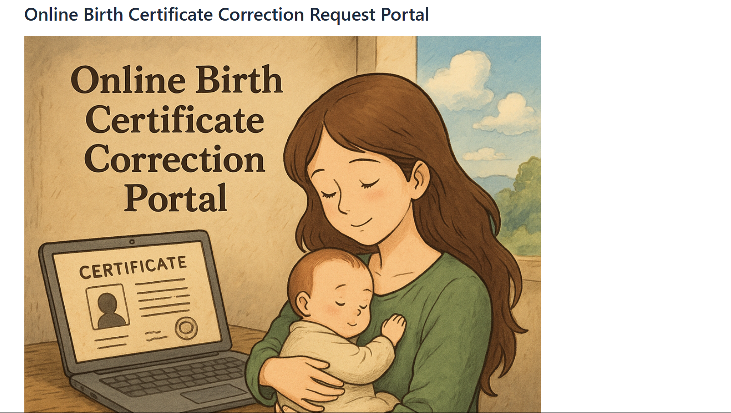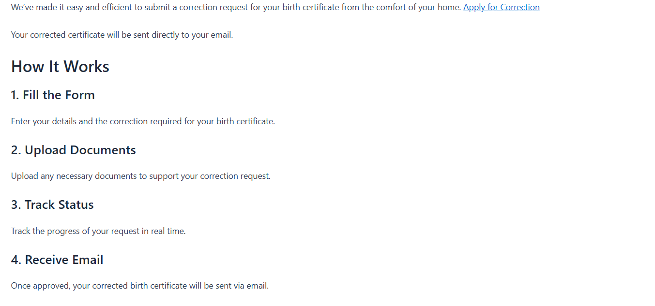

1. Apply for correction page

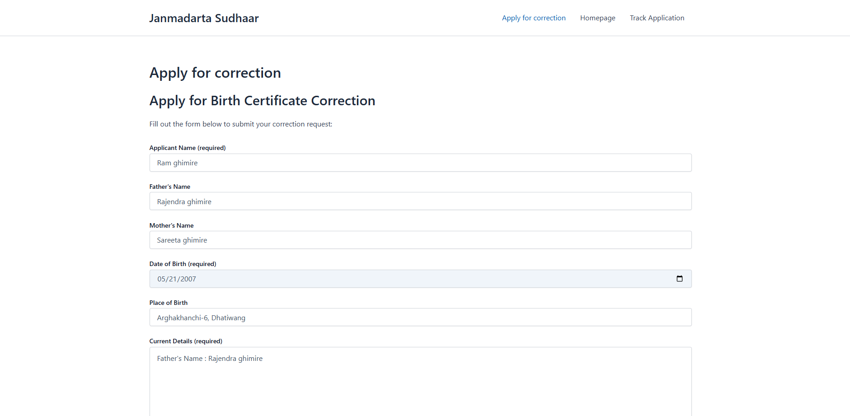 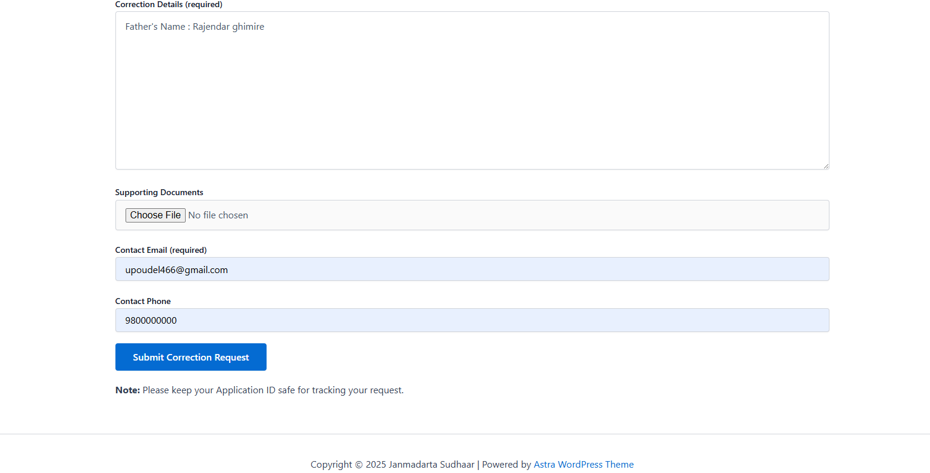 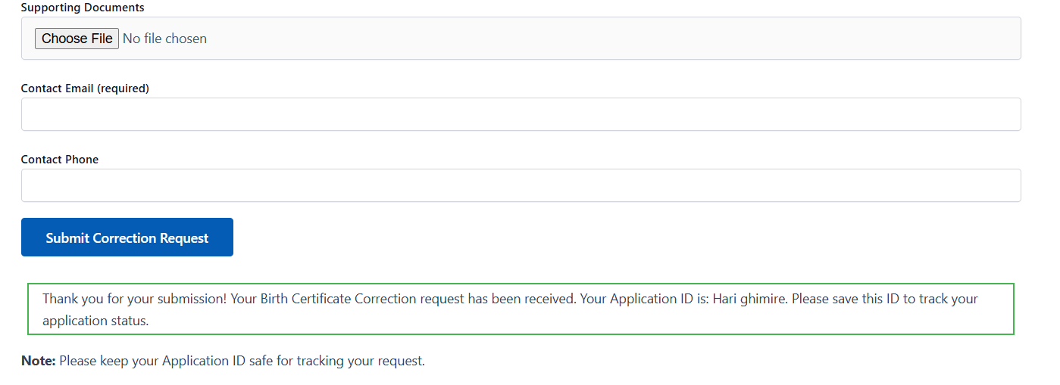

1. Tracking Your application

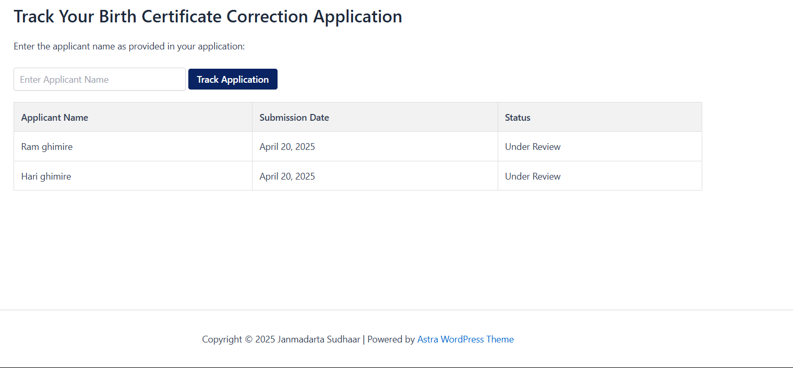 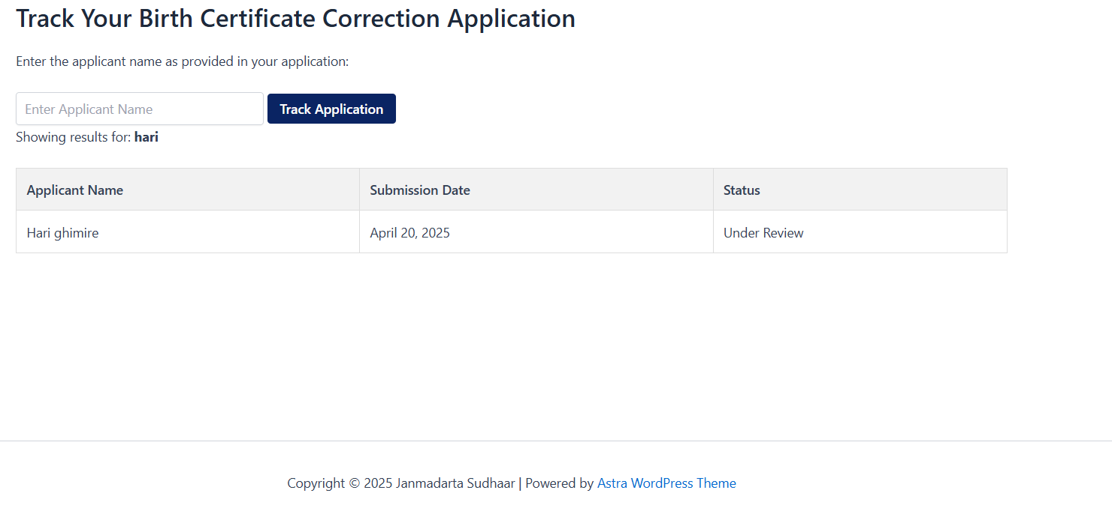

**Conclusion**

The development of the “**Janmadarta sudhaar**” **Online Birth Certificate Correction Request Portal** represents a significant step toward digitizing and simplifying essential civil services. By transitioning the correction request process from traditional, manual methods to a secure, web-based platform, this system ensures greater accessibility, transparency, and efficiency for both users and administrative authorities.

Through features like user registration, structured correction forms, document uploads, real-time tracking, and an intuitive admin panel, the portal addresses common pain points faced by citizens, such as long queues, unclear processes, and lack of communication. For administrators, the system offers streamlined management tools that enhance accuracy and speed in processing requests.

In an era where digital governance is becoming a necessity rather than a luxury, this project aligns with the broader goal of e-governance and public service automation. With future enhancements such as mobile app integration, multilingual support, and biometric authentication, the portal has strong potential to scale and evolve into a comprehensive civil documentation support system.

Overall, this project not only showcases technical capabilities in web development and system design but also emphasizes the real-world impact of thoughtful, user-focused digital solutions in improving government-citizen interactions.

**Reference**

1. **W3Schools Online Web Tutorials**  
   *HTML, CSS, JavaScript, PHP & MySQL Documentation and Examples*  
   <https://www.w3schools.com>
2. **PHP Manual – Official Documentation**  
   *Comprehensive reference for PHP programming language*  
   <https://www.php.net/manual/en/>
3. **MySQL Documentation – Oracle**  
   *Official reference for MySQL database usage and queries*  
   <https://dev.mysql.com/doc/>
4. **Bootstrap Documentation**  
   *Front-end component library used for responsive UI design*  
   <https://getbootstrap.com/docs/>
5. **Government of Nepal – Department of Civil Registration**  
   *Procedures and regulations regarding birth registration and corrections*  
   <https://docr.gov.np/>
6. **Stack Overflow Community Discussions**  
   *Common solutions and programming discussions related to form handling and server-side validation*  
   <https://stackoverflow.com>